2025 Dates

January 18th Ice Castles in Cripple Creek

# February

<https://gobreck.com/seasons/winter-spring/breckenridge-dog-sledding>

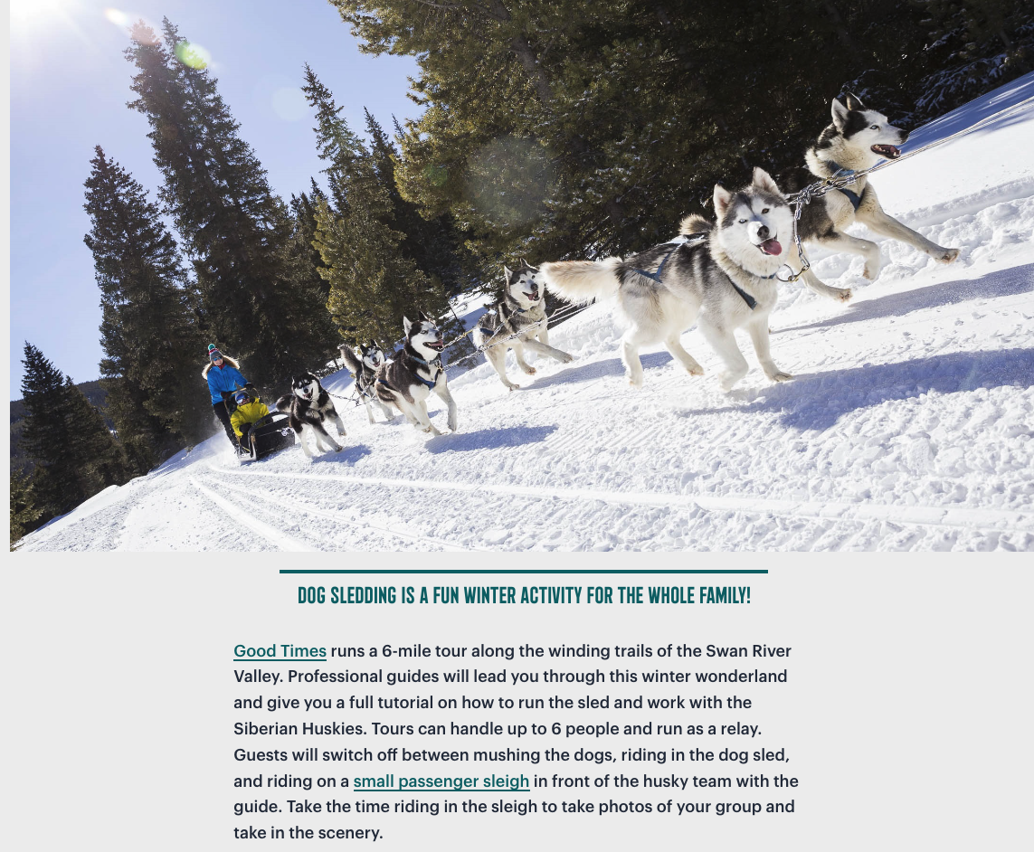

<https://goodtimesadventures.com/dogsledding.html>

February 1 (Saturday) at 12:30 PM





# March

Rage Room  
March 21 @ 5:20

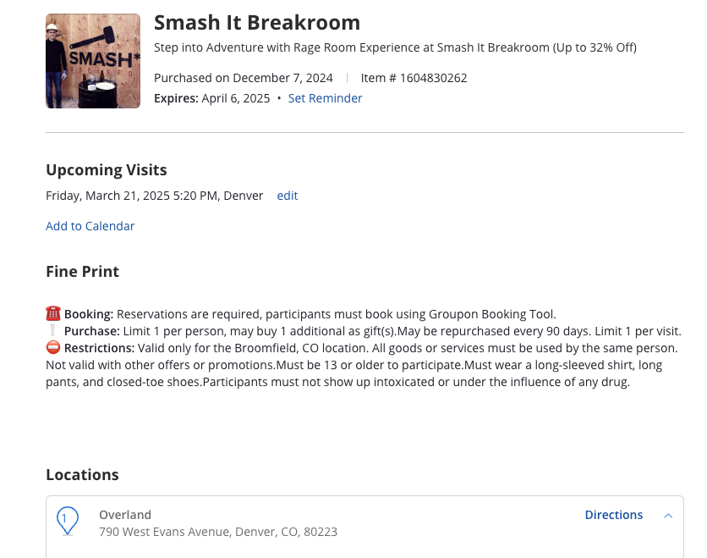

# April

Left Hand RiNo

Beer, Lunch and walk around RiNo taking pictures and lunch at Left Hand Rino.

4180 Wynkoop St. Suite 140

<https://lefthandbrewing.com/rino>

Free

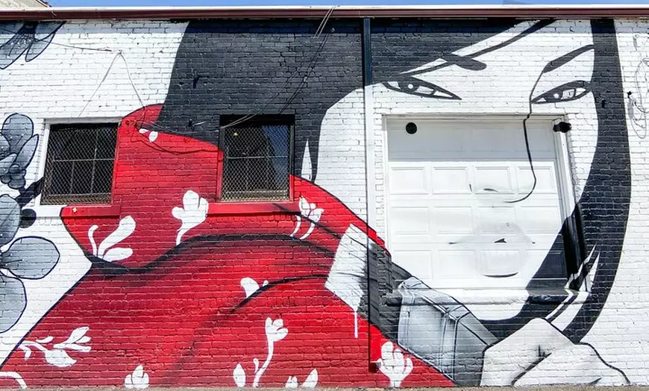

# May

Bear Creek Greenbelt Park

Mountain Bike

Free

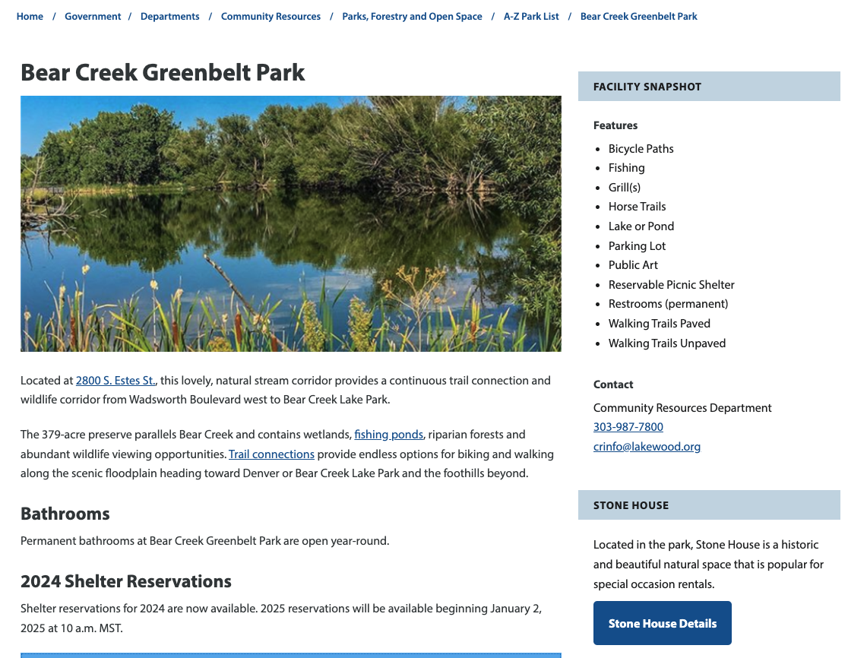

# June

Castlewood Canyon State Park

Photography and Hiking

<https://www.tripadvisor.com/ShowUserReviews-g33430-d614116-r298491767-Castlewood_Canyon_State_Park-Franktown_Colorado.html>

<https://cpw.state.co.us/placestogo/parks/CastlewoodCanyon>

**Castlewood Canyon State Park is a Colorado state park near Franktown, Colorado. The park protects a unique part of Colorado's history (the Castlewood Canyon Dam).**

​​​​​​​​​​​​​​​​​​​​​​​​​​​​​​​​​​​​​​​​​Nature lovers and groups enjoy environmental diversity on several hiking trails ranging from mild to moderate. The trails range from .5 to 4 miles and can be combined for longer journeys. The winding Cherry Creek flowing along the canyon floor provides wonderful rest stops. ​Pets, **on a leash**, are welcome on most trails, except the new East Canyon Preservation Area trail.

The natural amphitheater and the Bridge Canyon Overlook gazebo perched on the edge of the canyon are unique places for weddings or other outdoor ceremonies. Casual groups and families enjoy the picnic areas at both entrances. Remnants of geologic and local history combine when the then Castlewood Dam burst in 1933, sending a 15-foot-high wave of water into Denver. Ruins of the original ill-fated dam and the historic homestead still exist for hikers to see.

No Dogs or other pets are permitted

Free

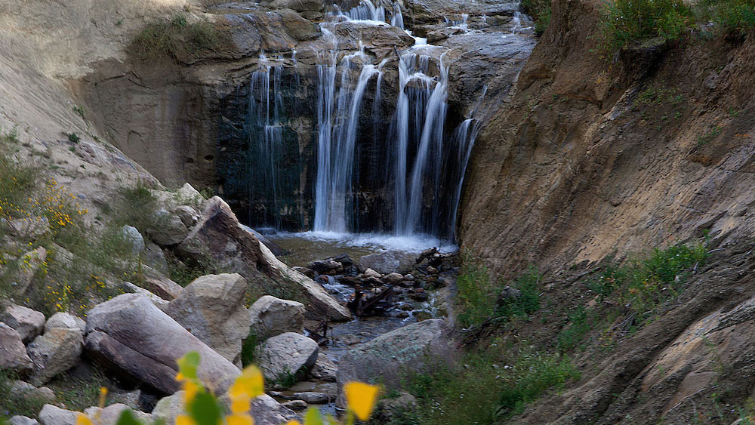

# July

Mountain Bike in Estes Park

<https://www.visitestespark.com/things-to-do/outdoor-adventures/biking/>

Estes Park is the year-round adventure playground of Colorado and the base camp for Rocky Mountain National Park. With seemingly endless outdoor activities, there is truly something for every one.

Need to board Meg for the weekend and schedule Worldmark reservation Friday & Saturday.

**Mountain Biking**

For mountain biking trails in Estes Park, Roosevelt National Forest offers the most abundant opportunities, as Rocky Mountain National Park doesn't allow mountain biking on their trails. Dozens of trails cover hundreds of miles in this preserved area. Pedal through pine-filled forests, across open grasslands and into terrain studded with rocks and hills. An intermediate favorite that's also popular with [ATV](https://www.visitestespark.com/things-to-do/outdoor-adventures/off-roading/) enthusiasts: Pole Hill. Ride the loops here with care; epic boulders show up unexpectedly around curves. The descents on this almost-single track will leave you breathless and delighted.

East of Estes Park about two miles is [Hermit Park Open Space](https://www.larimer.org/naturalresources/parks/hermit-park), a Larimer County recreation area with access to the national forest trails. In addition to camping, cabins and hiking, mountain bikers can access the bike-friendly Moose Meadows Connector Trail. This trail is 1.1 mile within Hermit Park, connecting to 12 miles of national forest trail. Plus, don't miss out on the new Limber Pine Trail. Find additional information, including maps, directions and access fees at [here](https://www.larimer.org/naturalresources/parks/hermit-park).

The one sweet spot for mountain biking enthusiasts in [Rocky Mountain National Park](https://www.visitestespark.com/rocky-mountain-national-park/) is Old Fall River Road. Once open for the summer, this is a cars-only, one-way gravel road that climbs to the Alpine Visitor Center. However, mountain bikers flock to the switchbacks before and after the seasonal vehicle period to take advantage of the amazing views and unique thrills.

**Leisure Bike Trails**

Fans of cruiser bikes appreciate the Lake Estes Bike Path because they don't have to compete with cars, the views are stunning, and they can pedal at a leisurely pace. Thanks to nearby bike rentals and the ease of the route, out-of-town families often turn the picturesque 3.75-mile loop into a pleasant outing that even youngsters enjoy.

Those looking for an extended ride can take the lake trail south, under the highway and through Stanley Park. This route continues south along Fish Creek, where cyclists can head west along the ponds at the Carriage Hills neighborhood, or continue south along Fish Creek to explore the beaver dams.

The Lake Estes Trail also connects with the downtown [River Walk](https://www.visitestespark.com/things-to-do/outdoor-adventures/scenic-walks-and-trails/), where cyclists are asked to hop off & walk. The slower pace lasts just a few blocks and allows riders to take in the beautiful flower beds, stop for a bite or grab some additional gear. West past the downtown area cyclists can mount up and continue along the scenic Fall River, where the trail meets up with many riverside lodging properties.

# August

Axe Throwing at American Paintball Coliseum

<https://www.americanpaintballcoliseum.com/denver-axe-throwing/>



# September

First Friday Art Walk



# October

<http://www.emmacrawfordfestival.com/>

Will have to check exact date

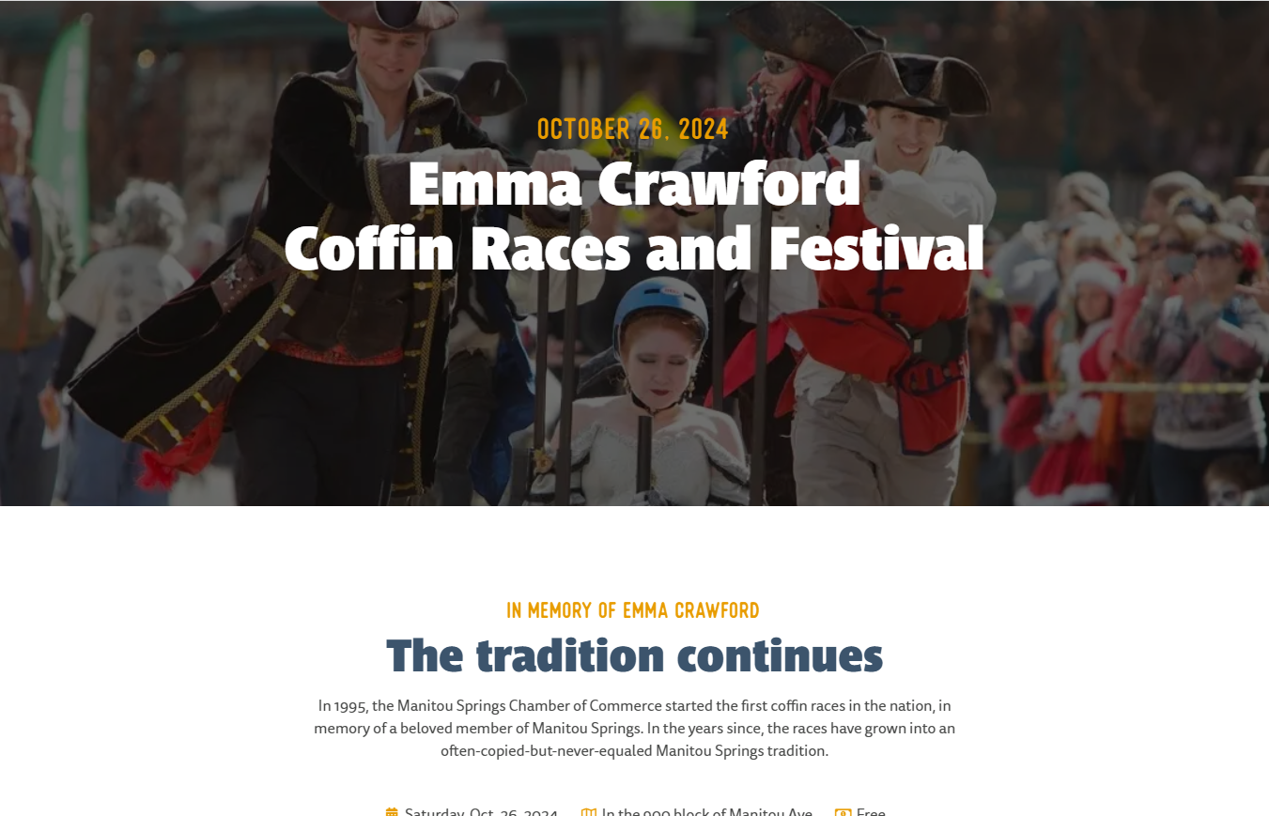

# November

Snowshoeing

<https://www.westword.com/arts/get-outside-ten-scenic-snowshoe-trails-near-denver-15695763>

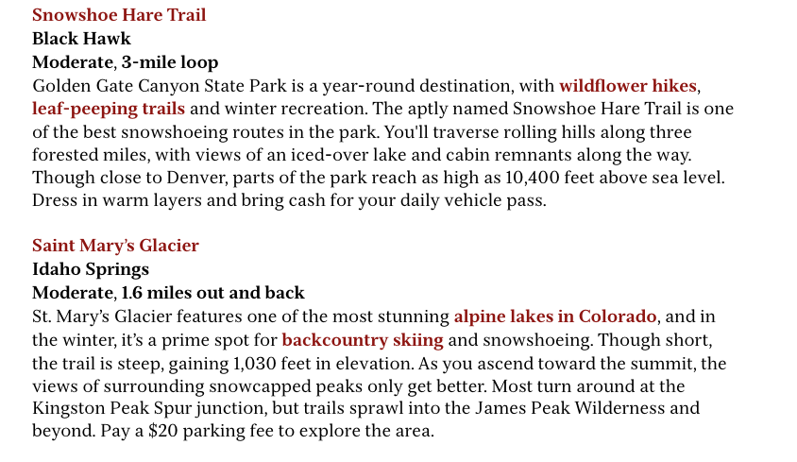

# December

Roxborough State Park

Photography, Snow Shoeing and Hiking

<https://cpw.state.co.us/placestogo/parks/Roxborough>

No Dogs - Free

